 | Lesson 1 - ir | Lesson 2 - ir | Lesson 3 - oy | Lesson 4 - oy | Lesson 5 - Rainbow
Revise & Review | Sound recap set 1  Action poem interactive activity | Sound recap set 2 | Sound recap set 1  Action poem interactive activity | Sound recap set 2 | Rainbow words – revise words
Teach | Carpet session: Alternative ‘ir’ | Interactive Lesson: alternative ‘ir’ | Carpet session: Alternative ‘oy’ | Interactive Lesson: alternative ‘oy’ | Rainbow Words interactive activity
Practise | Worksheet: Yucky Yak | Worksheet: Digraph detective | Worksheet: Yucky Yak | Worksheet: Digraph Detective | Spelling worksheets
Apply (Plenary) | Read: Print and cut out word cards. Support children sorting real and pseudo words. | Write: On mini whiteboards or on paper, support children to write: This is my third shirt. | Read: Print and cut out word cards. Support children sorting real and pseudo words. | Write: On mini whiteboards or on paper, support children to write: The boy enjoys the toy. | Read: Print and cut out Rainbow Words. Support children to read the words: first, girl, birds, boy.
Assess | Can children blend together the focus real words and pseudo words containing ‘ir’? | Can children identify digraphs ‘ur’ and ‘ir’ within text?  Can children segment words containing ‘ir’? | Can children blend together the focus real words and pseudo words containing ‘oy’? | Can children identify digraphs ‘oi’ and ‘oy’ within text?  Can children segment words containing ‘oy’? | Can children identify the focus graphemes in their Top 300 Rainbow Words?  Can children blend together the Rainbow Words containing the focus graphemes?
 | Learning Objective
Focus GPCs:  Alternative Alternative  ir oy  Top 300 high-frequency words:  First, girl, birds, boy | - Practise previously learned graphemes.  - Learn new graphemes ‘ir’ and ‘oy’  - Practise blending and reading words containing ‘ir’ and ‘oy’.  - Practise spelling and segmenting words containing ‘ir’ and ‘oy’.  - Learn to read and spell high-frequency words: first, girl, birds, boy.  - Read or write sentences containing high-frequency words and this week’s focus graphemes.
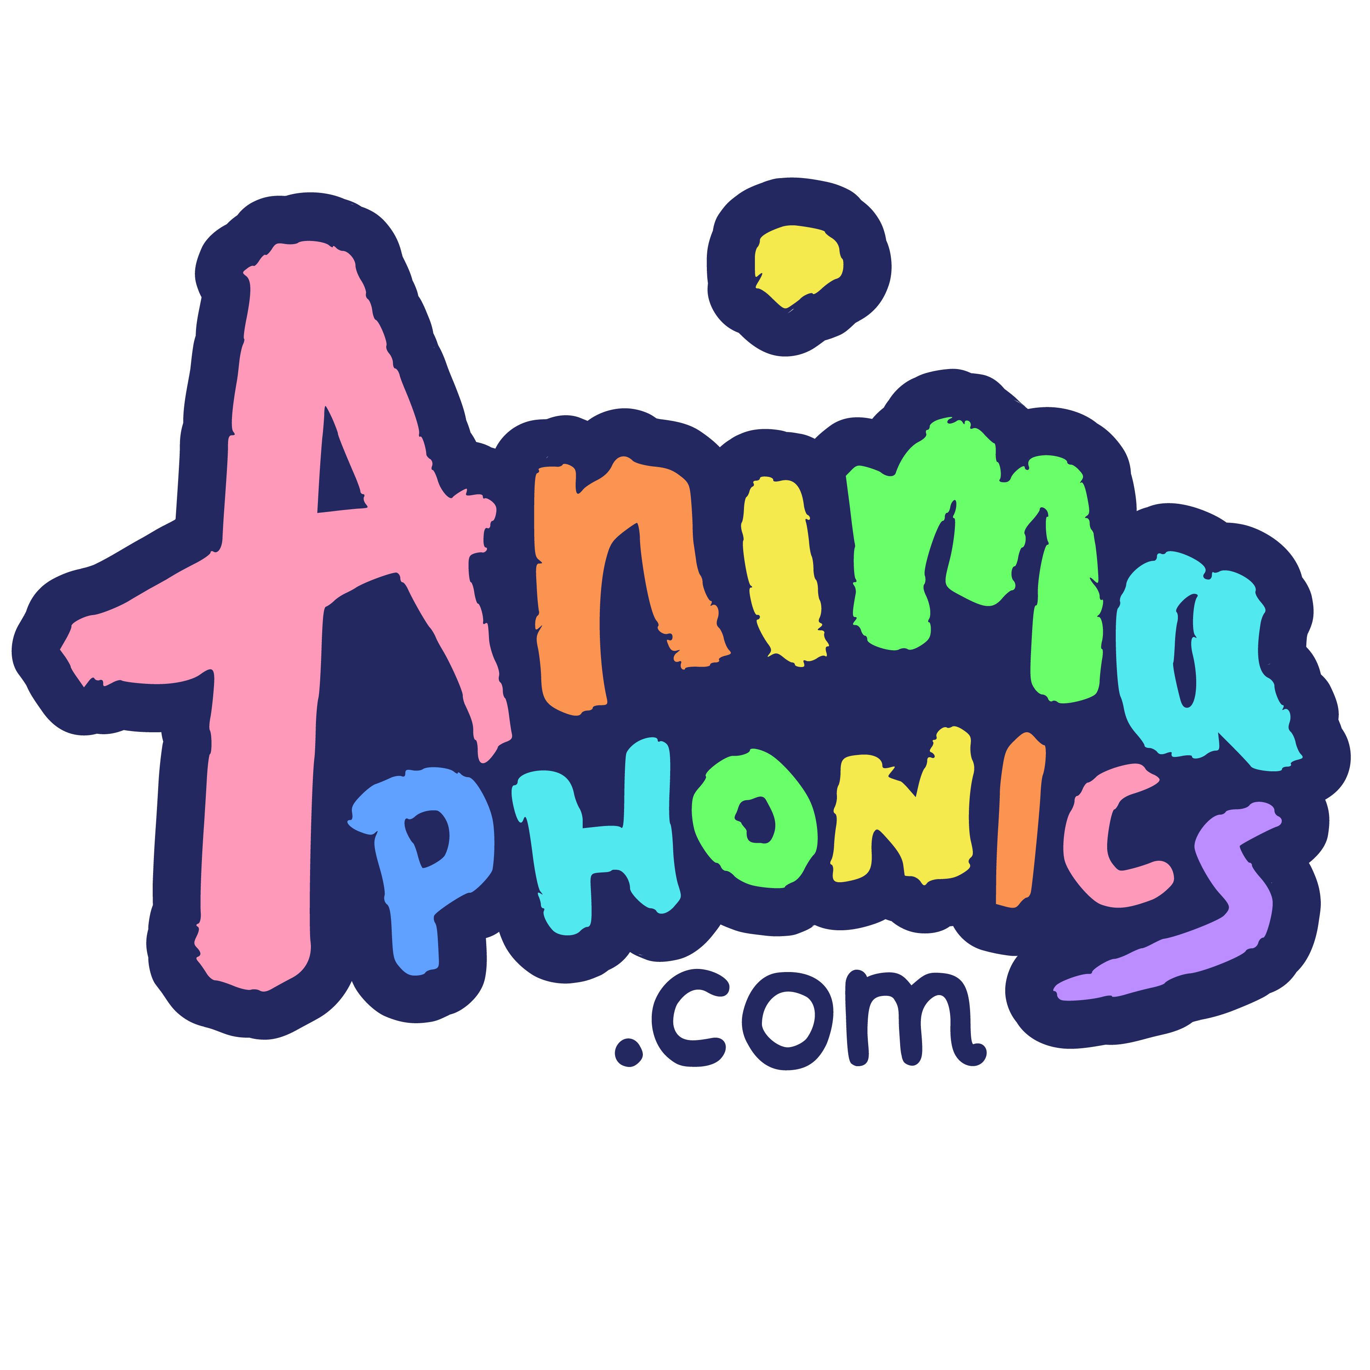
Extended Code 2 – Plan 1

